Solution Design Document

QAD Download Report

**Process Name**: QAD Download Report

**Prepared by**: Novigo Solutions

**Date Prepared**: 28-11-2019

**Last Updated**: 28-11-2019

**Version**: 1.0

TABLE OF CONTENTS

1 DOCUMENT HISTORY 3

2 DEVELOPERS 3

3 GLOSSARY OF TERMS 3

4 DATABASE 3

5 SQL QUERIES 3

6 DETAILED PROCESS FLOW 4

7 FLOW CHART 6

8 EXCEPTIONS 7

9 PROCESS CONFIGURATION 7

# DOCUMENT HISTORY

|  |  |  |  |
| --- | --- | --- | --- |
| **Version** | **Description** | **Date** | **Author** |
| 1.0 | Initial Draft | 28-11-2019 | Shishir |

# DEVELOPERS

|  |  |
| --- | --- |
| **Name** | **Package Version** |
| Shishir |  |

# GLOSSARY OF TERMS

The following table includes definitions for any abbreviations or notations that are used in the document:

|  |  |
| --- | --- |
| **Term** | **Definition** |
| RPA | Robotic Process Automation |

# DATABASE

Three tables are created in the Database:-

1. ODS_TG1_BalanceSheet

FIELDS:

* QAD_Id (primary Key)
* QAD_FileName
* QAD_PlacedInFolder
* QAD_Exception
* CreatedDate

# SQL QUERIES

1) Insert query is used to keep track of the downloaded file in RPA Staging Table

**“**INSERT INTO QAD_Download_Reports ( QAD_FileName, QAD_PlacedInFolder, CreatedDate) VALUES ('"+in_FileName+"','Success',CURRENT_TIMESTAMP)**”**

# 6 DETAILED PROCESS FLOW

Step 1 – Robot will login to QAD with valid credentials.

Step 2 – Robot will read all the menu options from the input file.

Step 3 – Menu option is entered in QAD and following input is given.

|  |  |  |
| --- | --- | --- |
| **Menu** | **Menu Option** | **Field - Input** |
| Allocation | 36.10.20.20.2 | * Enter the Year – Current year * Output- 32prn |
| Sales | 36.10.20.20.3 | * To – Input will be start date of the month to today -1 (if we run the report on the first day of next month then it will be start date of previous month) * From- Starting date of “To” date * Output- 32prn |
| Transfer | 36.10.20.20.4 | * Site – 982(Take from config) * To(Site) - 982(Take from config) * To(date) – Input will be start date of the month to today -1 (if we run the report on the first day of next month then it will be start date of previous month) * Effective- Starting date of “To” date * Customer-ca106a(Take from config) * To(Customer)- ca106a(Take from config) * Output- 32prn |
| Scrap | 36.10.20.20.5 | * To – Input will be start date of the month to today -1 (if we run the report on the first day of next month then it will be start date of previous month) * Effective - Starting date of “To” date * Output- 32prn |
| Exchange rate | 36.10.20.20.6 | * Year – Current year * Month – Current Month * Output- 32prn |

Step 4 – The 32prn printer window will pop up and following actions takes place

* If pop up is successful, send to excel option is clicked.
* If pop up is not successful, that particular transaction is skipped

Step 5 – The Excel Window opens and following actions takes place.

* If window opens is successful, file is saved to particular path.
* If window does not open, that particular transaction is skipped

Step 6 – Same steps are followed for all the transaction and Robot will disconnect from QAD.

# FLOW CHART

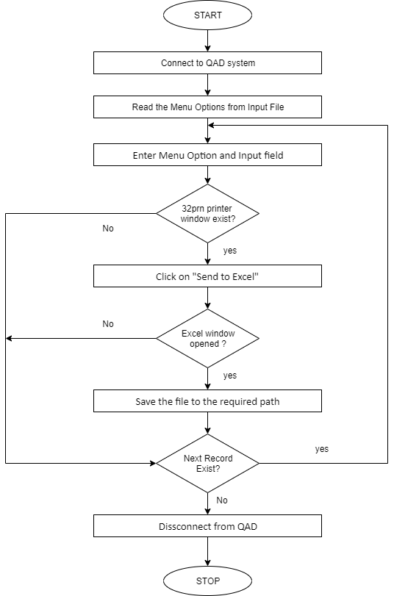

# 8 EXCEPTIONS

1. **Application Exception**

|  |  |  |
| --- | --- | --- |
| **SL NO** | **EXCEPTION** |  |
| 1 | Database connectivity issues | Connection has to be stable |
| 2 | QAD connectivity issues | Connection has to be stable |

1. **Business Exception**

|  |  |  |
| --- | --- | --- |
| **SL NO** | **FIELD** | **EXCEPTION** |
| 1 | Output | Output device entered is not a defined printer |
| 2 | Batch ID | Batch control record does not exist for this Batch ID |
| 3 | From Date/To Date(invalid month) | Month of a date should be from 1 to 12 |
| 4 | From Date/To Date (Invalid day) | Day in a month is invalid |
| 5 | From Date/To Date (Invalid year) | Invalid period/year |
| 6 | Year | Invalid Format – Year should be greater than 2000 |

# 9 PROCESS CONFIGURATION

1 - “Config.xlsx” Contains all the Config data like Email credentials etc. used in the Process.